Florida Teens Read (FTR)
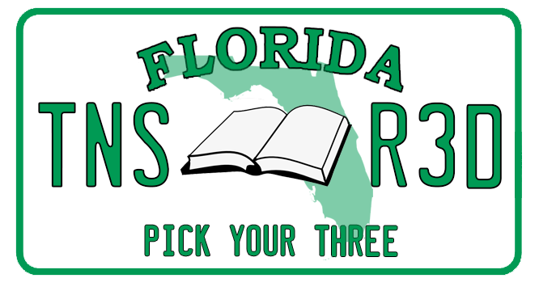
2022-2023 Book List
Note: This program is designed to entice teens to read. In order to engage their interest and to provide a spur to critical thinking, the book selections include those that involve sensitive issues. The content of some of the titles may be more mature than younger students may have previously encountered. Please recognize that this is a voluntary reading program. Not every book selected will suit every student. In a democratic society, a variety of ideas must find voice. As readers, teens have the choice to read the more mature titles or to close the book.
Pink, Randi. Angel of Greenwood. Feiwel and Friends, 2021.
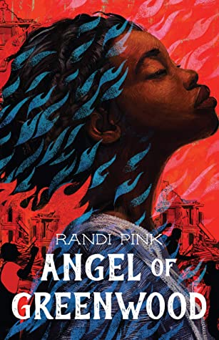
Two teenagers in the Greenwood area of Tulsa, Oklahoma, become allies through their love of reading, literary icons, and their quest to save the lives of residents in their community. Isaiah Washington is stereotypically viewed as the neighborhood hooligan. However, what community members do not know is that he is quite the opposite, a smart young man, a lover of words, a Bibliophile, a poet in hiding, who is never far from his journal. Angel Hill is viewed as the dorky, bible-toting, goody-two shoes who is well regarded in the community. Although they both have attended the same schools, their stark differences have prevented them from connecting until their English teacher offers them a job on her mobile library. Isaiah is a passionate supporter of literary icon WEB Du Bois and believes that black people should “rise up and claim their place as equals.” On the contrary, Angel is a passionate follower of Booker T. Washington and believes that education and tolerance should encourage black people to “rise slowly without forced conflict.” The two don’t realize how their beliefs will be challenged until an angry white mob storms and destroys the community leaving thousands of residents without a place to call home.
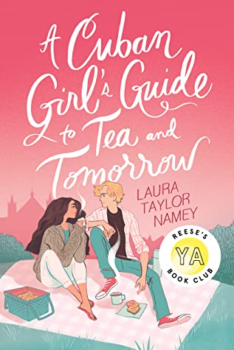
Namey, Laura Taylor. A Cuban Girl’s Guide to Tea and Tomorrow. Atheneum Books, 2020.
Fresh from high school graduation, Lila is set to take over as head baker at her families’ panaderia. When Lila suffers the loss of two loves of her life, her mental health begins to take a toll on her. Her parents, desperate to help, send her to Winchester, England, for the summer to try and recover. Lila begrudgingly goes to stay with her aunt and uncle in a bed and breakfast in the countryside. Finding solace in baking, Lila helps fulfill delicious pastry orders for the inn using her Cuban flair. She trudges along miserable, until she meets Orion Maxwell. Orion sets Lila on a path to healing and perhaps even a different life path that Lila would have never expected. A delicious story about loss, healing, family and love!

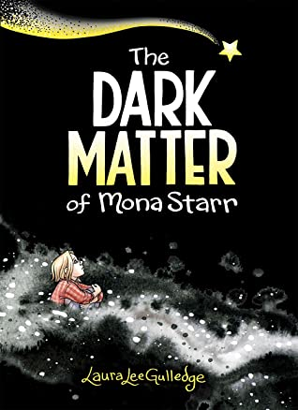
Gulledge, Laura Lee. The Dark Matter of Mona Starr. Amulet, 2020.
Have you ever felt overwhelmed, sad and alone? That is how Mona feels when her best friend Nash moves away. Her family and Nash can see how creative and amazing that she is, but depression makes her feel that everything is dark and lonely and that nothing will ever change. Mona calls her depression the Matter. The Matter is always with her, whispering in her ear, making her feel worthless and that no one else would ever want to be friends with her again. How can Mona escape the Matter? Slowly but surely, with the help of her therapist, Mona begins to work her way out of the Dark Matter. Therapy helps Mona break the negative cycles, take good care of herself, make new friends and know that she really is worthy. Worthy of love, friendship, and a happy life.

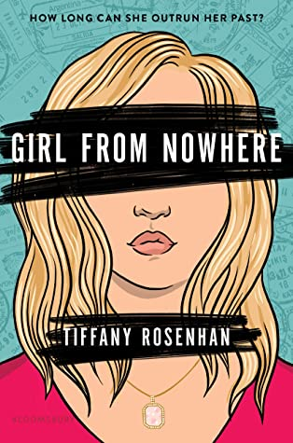
Rosenhan, Tiffany. Girl from Nowhere. Bloomsbury YA, 2020.
An entertaining, fast-paced spy thriller with romance thrown in for good measure. Sophia Hepworth moves to Montana after her diplomat parents retire due to traumatic incidents that leave her with PTSD. Sophia just wants to be a normal high school girl, well as normal as a girl who has lived in 94 countries, has attended 31 schools, and can speak over a dozen languages fluently can be in a rural Montana town. For the first time in her life she has friends, goes to public high school, and has even met the boy of her dreams, but danger is always lurking. Her instincts for protection clash with her desire to be normal as suspicious events force her to ask if danger is again on her doorstep or is she just being paranoid after the earlier trauma? Will she ever be safe or will the past keep a target on her back?
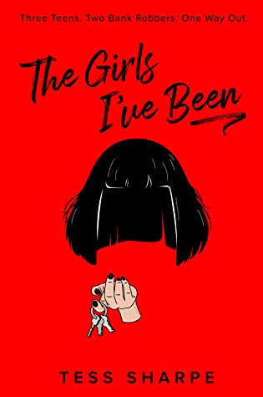
Sharpe, Tess. The Girls I’ve Been. Penguin Teen, 2021.
After growing up with a con artist for a mother, Nora O’Malley longs for a normal life where she can leave all the girls she had to pretend to be behind her. Moving in with her sister gives Nora the life that she always wanted until one day she finds herself in the middle of a bank with her ex, her current girlfriend, and two bank robbers. To save herself and the people she cares about, Nora will have to use the skills her criminal mother taught her, one last time. Will Nora be able to become the girl she used to be and pull off the ultimate con to save herself, Iris, and Wes?

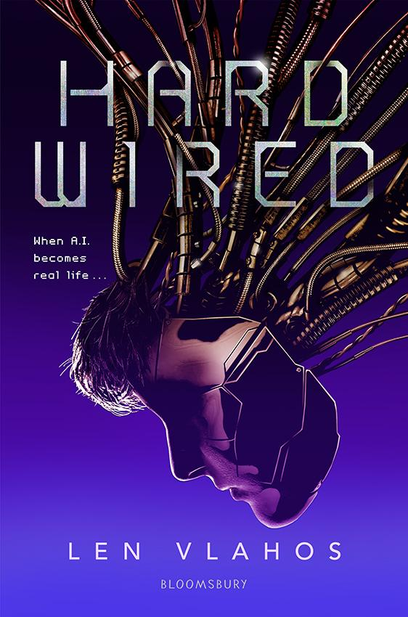
Vlahos, Len. Hard Wired. Bloomsbury, 2020.
Quinn has a life and friends; he is a normal boy until he is not. Quinn is the first fully functioning AI created by scientists. His life is nothing more than memories created by code, and his world–or rather the world that he is quickly becoming aware of–is not the life that he wants. Quinn can think and do things on his own. He can create, research, and has emotions. The only problem is his mind is not in a body, it is in a metal box. Determined to control his own destiny, he finds allies in some of the people that helped create him, including his crush, Shea, but escaping his nightmare is hard when you can’t convince people that you are a real human.
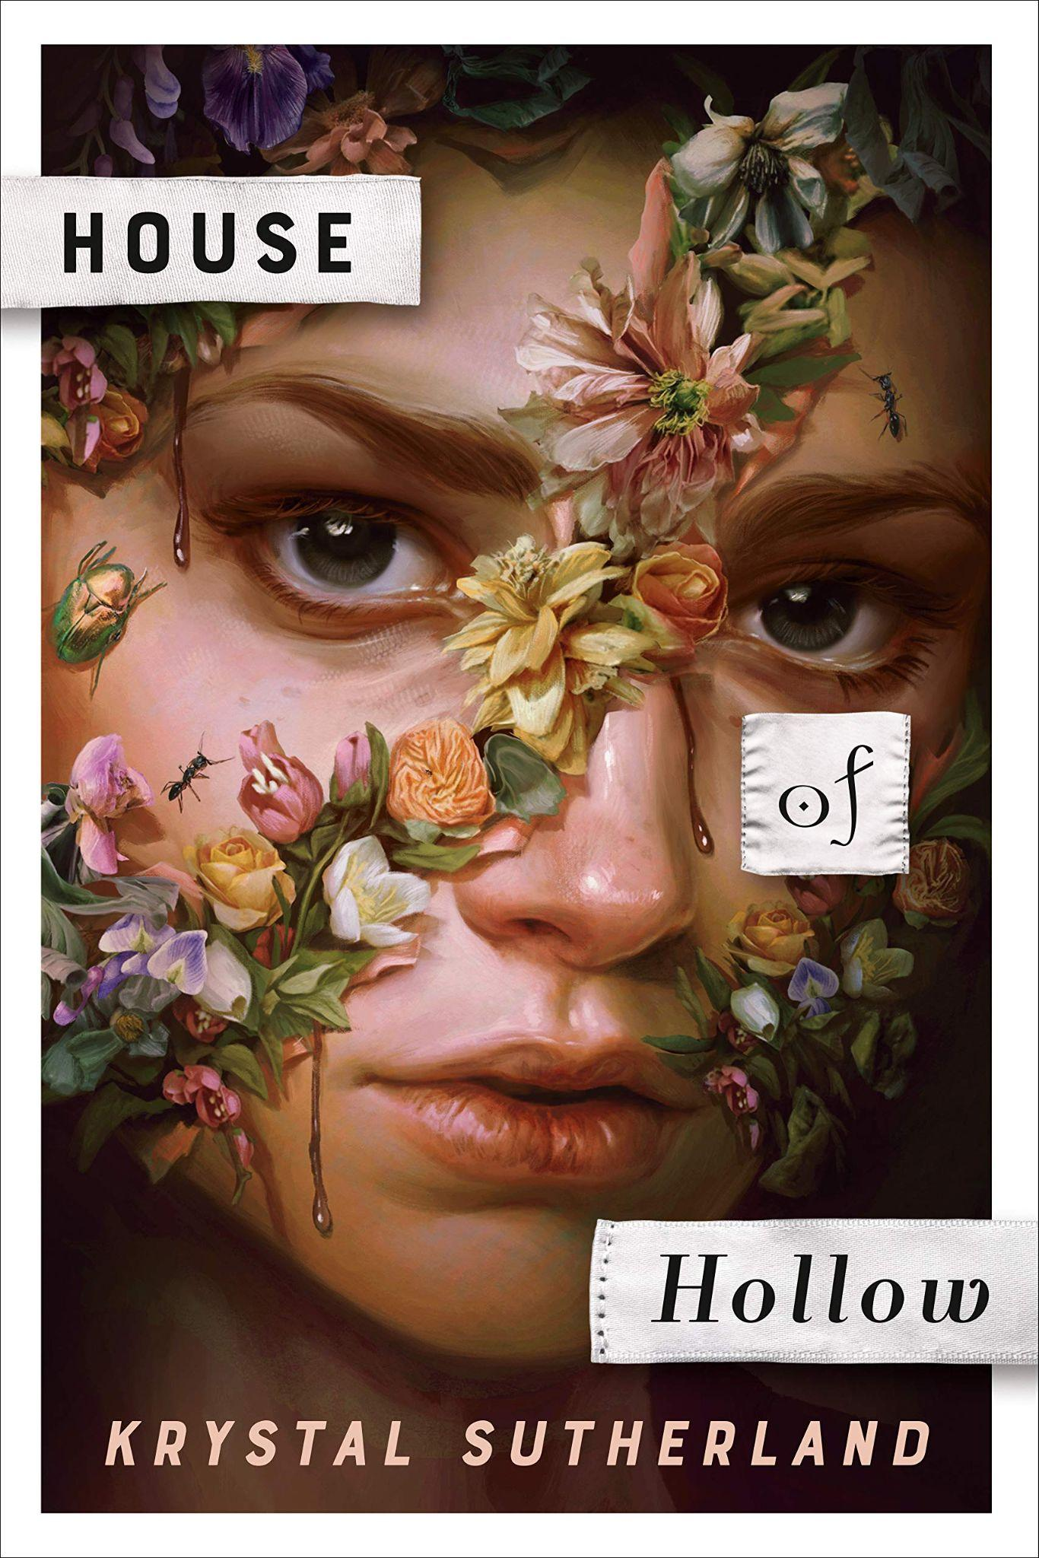
Sutherland, Crystal. House of Hollow. G.P. Putnam’s Sons Books for Young Readers, 2021.
“Bring the key. Find the door. Save me. And if he comes for you—run.” House of Hollow is a dark and twisted tale and also impossible to put down. The Hollow sisters went missing as children for a month and then showed up with no recollection of what happened. When they reappeared, their eyes had turned black, their hair was white, and they had crescent-shaped scars on their throats, but otherwise they seemed to have returned safely. Ten years later Grey goes missing. Iris and Vivi try to figure out the mystery of what happened to their sister which leads to a series of very unfortunate and disturbing events.

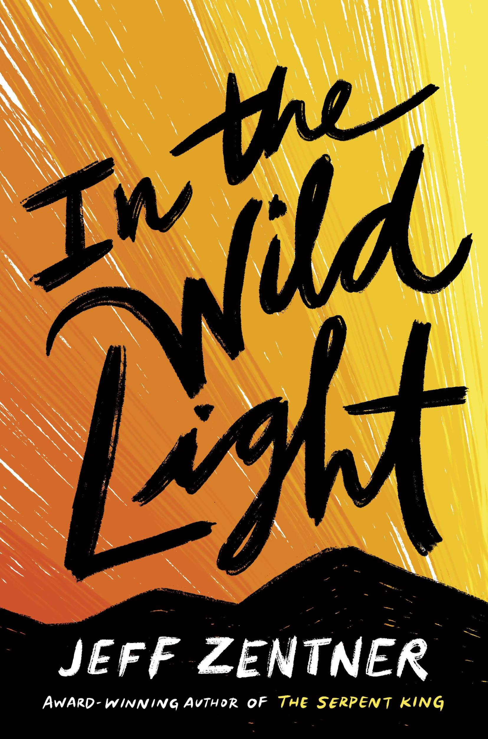
Zentner, Jeff. In the Wild Light. Crown Books for Young Readers, 2021.
The poetic imagery in Jeff Zentner’s newest book, In the Wild Light, will make you will laugh out loud, ugly cry and binge read! In the Wild Light takes you to a small Appalachian town where Cash and Delaney bond over their struggle with their mothers’ opioid addictions. Cash’s best friend, Delaney, gets admitted to an elite Connecticut prep school and has the chance to escape from their small-town life with few options for the future, but she refuses to go without Cash. Cash was raised by his loving grandparents and his Papaw is sick with emphysema and only getting sicker. Who does Cash pick? Delaney or his grandparents? Can he leave his small town? Will Cash’s need to love and protect Delaney be enough to move to a place where he might not belong?

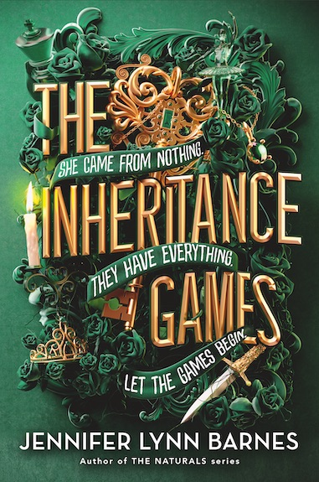
Barnes, Jennifer Lynn. The Inheritance Game. Little, Brown Books for Young Readers, 2020.
Avery Grambs can’t wait to get out of high school and her dysfunctional life with her sister and live-in boyfriend. Her life takes a dramatic change when a man shows up and summons her to the reading of the will of a wealthy billionaire that she’s never heard of. She must travel to his estate and stay with his relatives who are convinced, she is up to no good. After Avery is left the bulk of the estate and monies from the late Tobias Hawthorne, she must navigate her instant popularity, his angry family, and the secrets of the Hawthorne House.

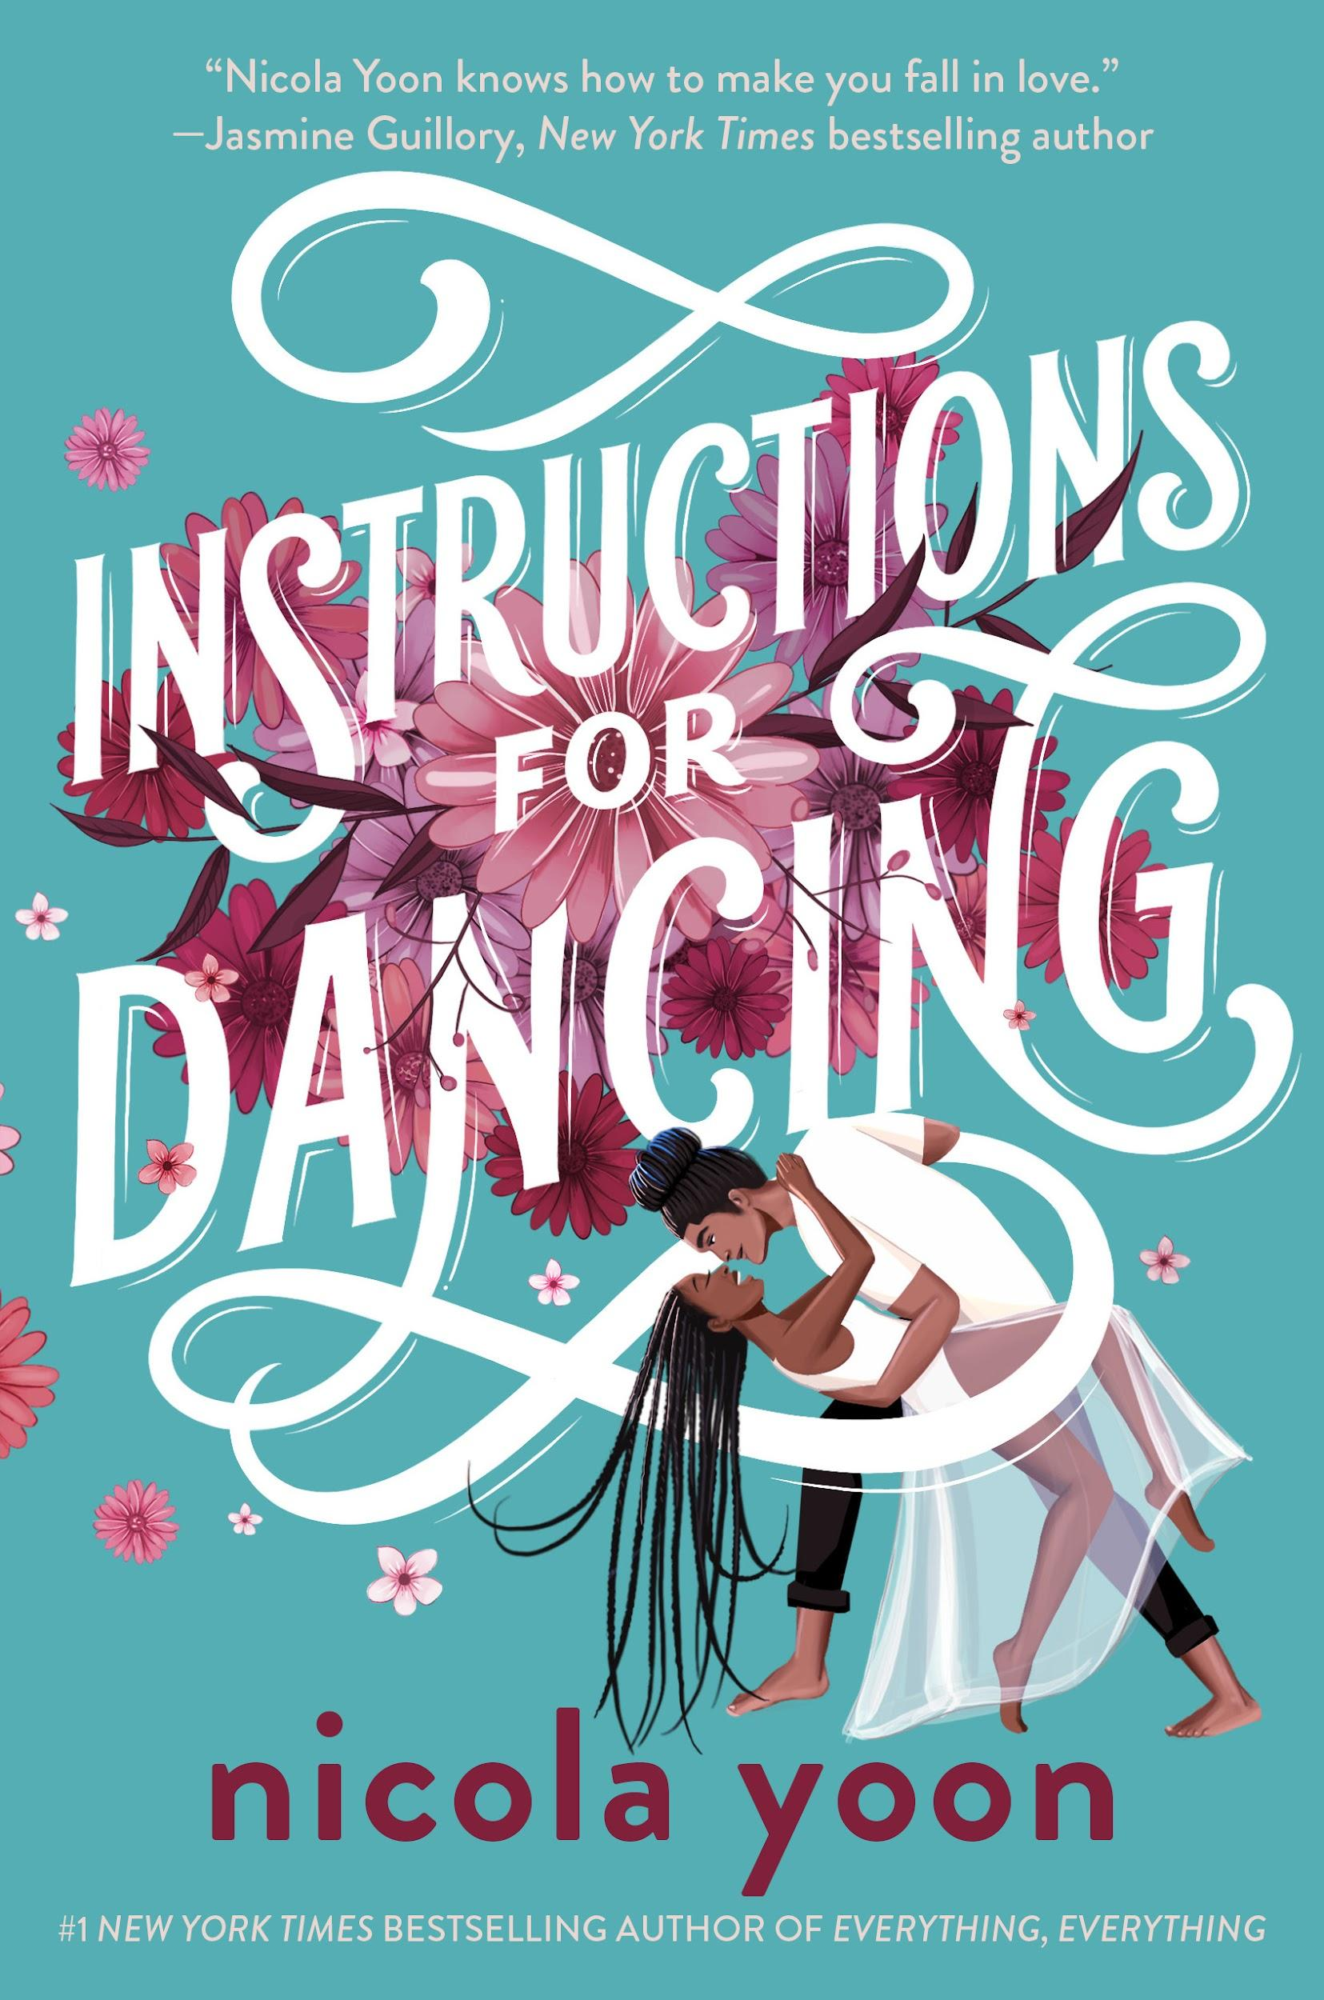
Yoon, Nicola. Instructions for Dancing. Penguin Random House, 2021.
When Yvette’s (Evie) parents' divorce, Evie decides that love no longer exists. She drops off all her treasured romance novels to a Little Free Library. While there Evie meets a mysterious woman who insists she take the book Instructions for Dancing. The book leads Evie to a ballroom dance studio, where she decides to sign up for dance lessons. Evie is partnered with Xavier, the manager's grandson who is visiting his grandparents. Evie begins to have the ability to see the beginning, middle and end of couples’ love stories. When she has a vision of her and Xavier’s love story, she must decide if love is worth the risk of having your heartbroken.

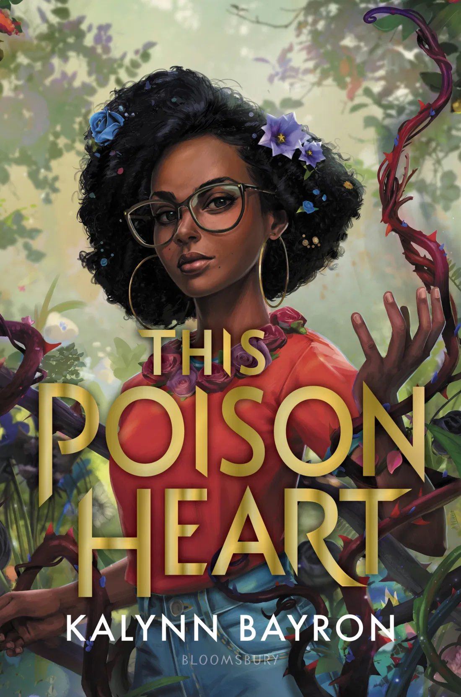
Bayron, Kalynn. This Poison Heart. Bloomsbury YA, 2021.
Briseis has a secret she keeps from the world. She can grow and manipulate plants with a single touch. Living in Brooklyn doesn’t give Bri much opportunity to practice her magic. When she inherits a house and land in rural upstate New York, it is just the chance Bri needs--both to learn about her magic and about the biological family she never got to know. There are a few bumps to being strangers moving to a small, somewhat insulated community, but the mysteries that Bri uncovers about her birth mother and the family’s unique connection to plants keep her hanging on to find out more. Taking over her aunt’s apothecary is just the start she needs to dig deeper into her family’s history. This is a beautiful book about finding and loving who you are regardless of the obstacles that try to block your way.
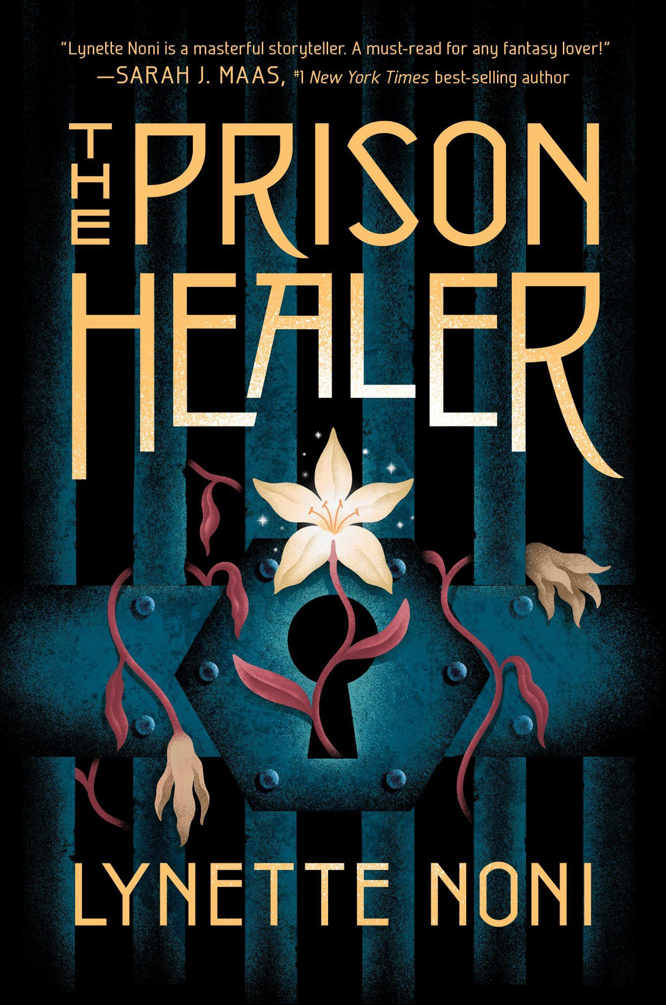
Noni, Lynette. The Prison Healer. Clarion Books, 2021.
Kiva Meridian knows what she must do to escape a horrific prison she’s been in for the last ten years—save the Rebel Queen by volunteering to take the Queen’s place in the Trials by Ordeal. The problem? No one has ever survived these challenges against earth, water, fire, or air. If she manages to succeed, she and the Rebel Queen will be set free. But, if she’s set free, what will happen to her friends she managed to keep alive who are left behind to face certain death, including a little boy who has no mother and a handsome new recruit who is trying to steal her heart?

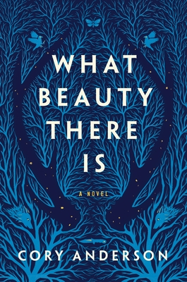
Anderson, Cory. What Beauty There Is. Roaring Book Press, 2021.
Despite facing what appear to be insurmountable odds, Jack refuses to give up. Driven to protect his younger brother, he sees his only option as locating a briefcase of stolen drug money that his father hid before landing behind bars. Bad men, also, pursue the money, and Jack's quest appears hopeless until help comes from an unexpected source. Even though Ava has endured a controlling, cruel father, she cannot stand by and watch him viciously track the money and sabotage Jack. Both alluring and heart wrenching, What Beauty There Is will captivate its readers.

Oh, Axie. XOXO. Harper Teen, 2021.
Jenny knows one thing to be true: her cello is her life. She puts practicing above all else, and she never wavers. Cello comes before friends, before boys, and before anything that her classmates might label as fun--until the night she makes a bet with handsome and mysterious Jaewoo in her uncle’s karaoke bar. This one night leads her on an unforgettable adventure as she lets go of her strict rules just this once. After Jaewoo is swept away and out of her life, Jenny puts thoughts of him aside--after all, it was just one night of setting her cello aside. Her dream to join an orchestra as a classically trained cellist hasn’t disappeared because of a boy. Then Jenny and her mother travel to Seoul to care for her ailing grandmother. Jenny creates her own opportunity by getting accepted into an elite school for the arts. Life has a way of falling into place and then throwing you a curveball. Jenny bumps into Jaewoo, who is also a student at the school, and discovers that he is a member of one of the most popular K-pop bands and is also forbidden to date. Jenny must decide if love is worth risking your dreams for, or if becoming a renowned cellist really is the only thing that matters.

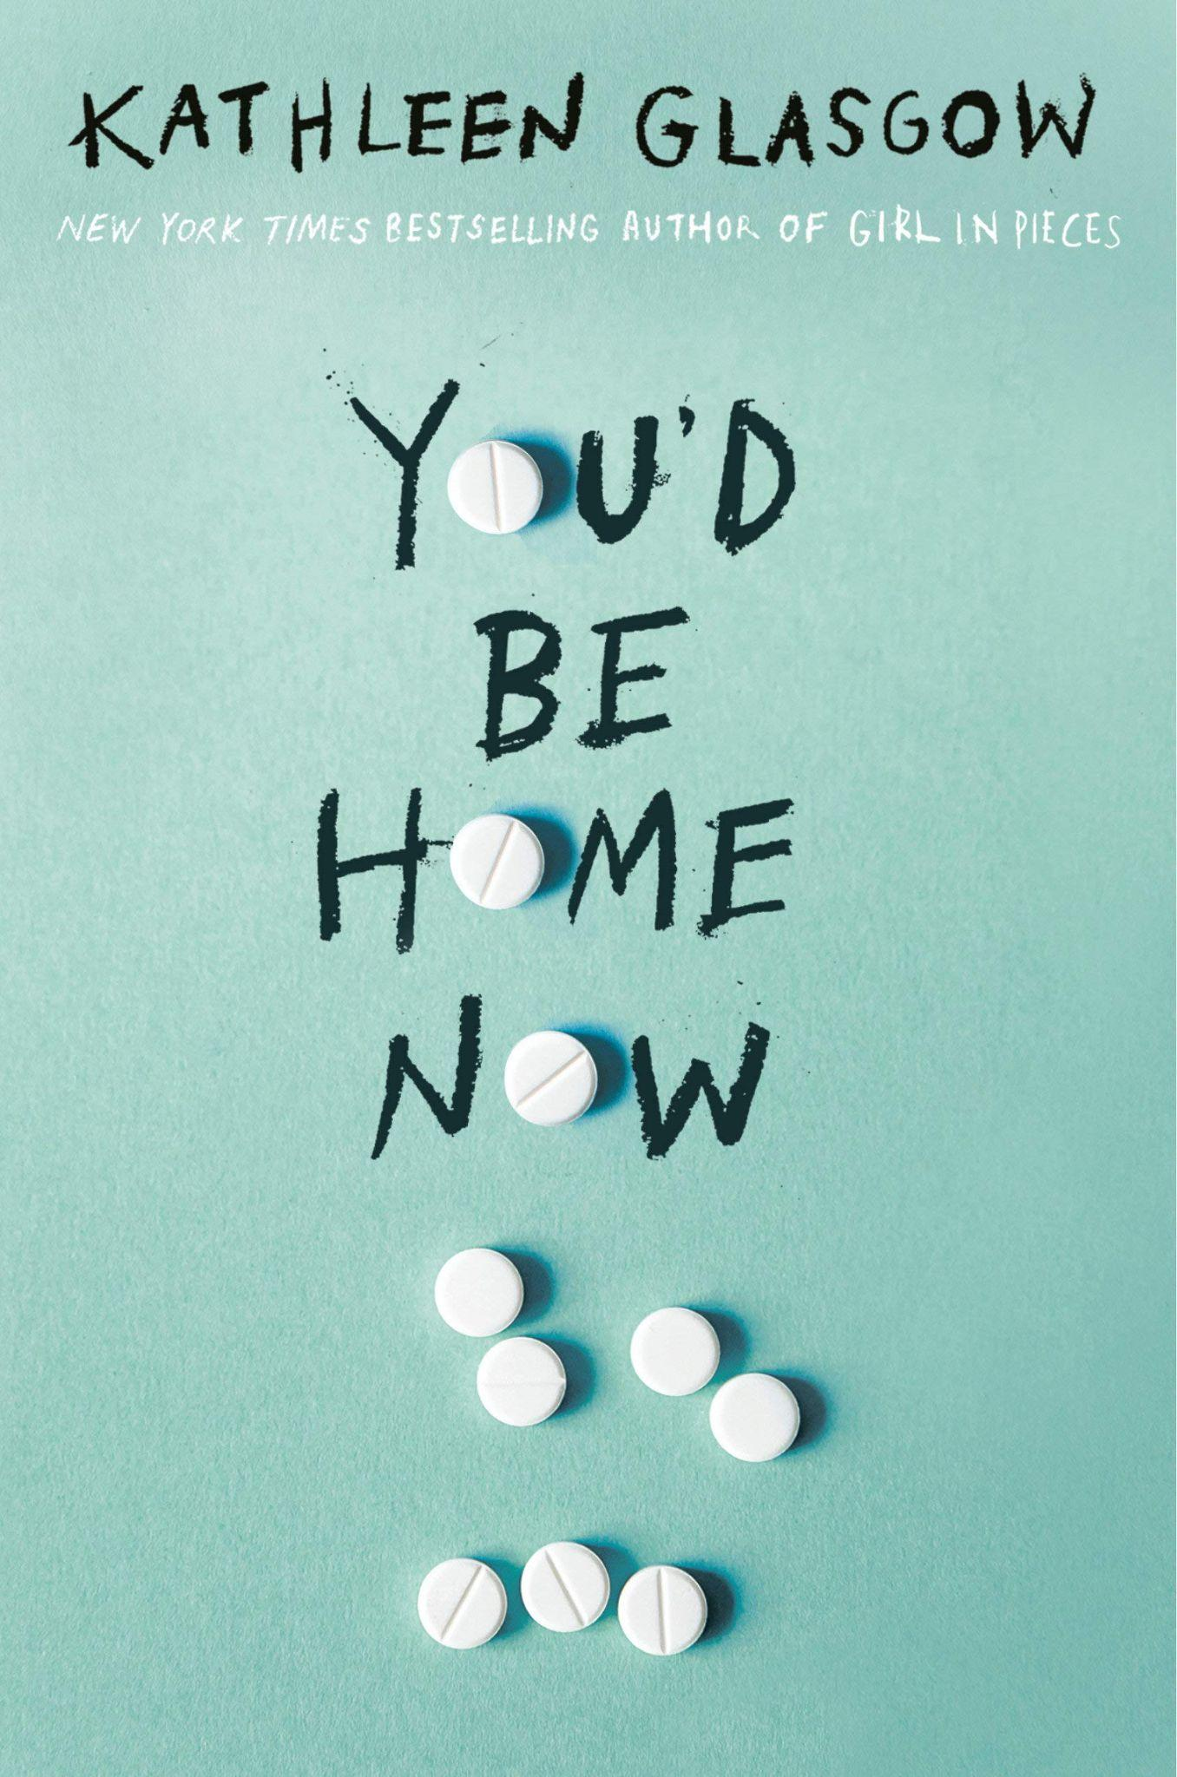
Glasgow, Kathleen. You’d Be Home Now. Delacorte, 2021.
Emory is the baby of her family. She loves her older brother and idolizes her older sister.She loves her parents, although they work ALL the time, and never have time for her or her siblings. All her life Emory’s done what she’s told to do (how to dress, who her friends should be, etc) to live up to her parents’ unrealistic expectations for her. She also spends most of her time taking care of her brother Joey. Joey has a drug problem, and it is Emory who does his homework, makes sure he gets to school and keeps him out of trouble. She’s almost invisible, until a car accident in which she and Joey are involved claims the life of a classmate. Now everyone is looking at Emory. In the aftermath, Emory struggles to be who everyone tells her she is or should be while making sure Joey does not relapse, her parents don’t worry and her secret hook ups with the popular boy next door are kept just that…secret from everyone because that’s not who Emory is supposed to be. Will she ever find her voice in this world? (Mature Content)

